

# Assignment - 3

## SAVEETHA SCHOOL OF ENGINEERING

Submitted by

**Madhu Balan I (192321142)**

Submitted to

# Dr. Christy Melwyn

Professor

Course Code: **CSA0556**

Course Name: **Database Management Systems for Relational Database**

## Question 1: Handling Division Operation

**Task:**

Write a PL/SQL block to perform a division operation where the divisor is obtained from user input. Handle the `ZERO_DIVIDE` exception gracefully with an appropriate error message.

## PL/SQL Block:

DECLARE

dividend NUMBER := 50; -- Example dividend

divisor NUMBER := 0;

result NUMBER;

BEGIN

-- Perform division

result := dividend / divisor;

DBMS_OUTPUT.PUT_LINE('Result: ' || result);

EXCEPTION

WHEN ZERO_DIVIDE THEN

DBMS_OUTPUT.PUT_LINE('Error: Division by zero is not allowed.');

END;

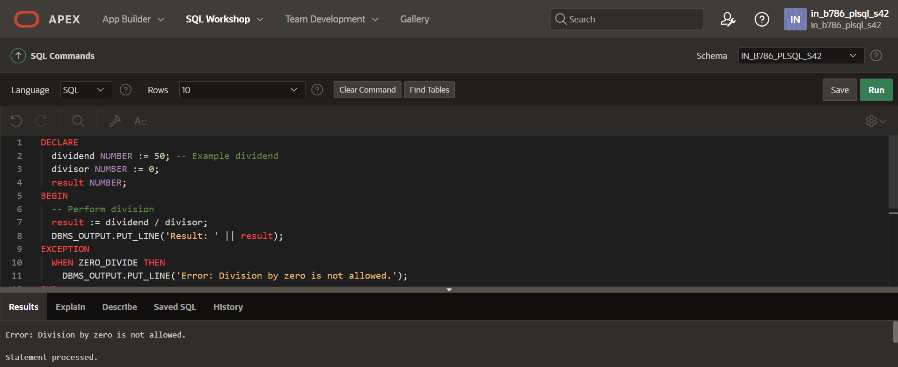

## Explanation of Error Handling Strategies:

* The `ZERO_DIVIDE` exception is specifically caught to handle cases where the divisor is zero, preventing the program from crashing and providing a user-friendly message.
* The `WHEN OTHERS` exception handler is a catch-all for any unexpected errors, ensuring that the program gracefully handles any unforeseen issue

## Question 2: Updating Rows with FORALL Task:

Use the `FORALL` statement to update multiple rows in the Employees table based on arrays of employee IDs and salary increments.

## PL/SQL Block:

DECLARE

TYPE emp_id_array IS TABLE OF NUMBER INDEX BY PLS_INTEGER;

TYPE salary_increment_array IS TABLE OF NUMBER INDEX BY PLS_INTEGER;

emp_ids emp_id_array;

salary_increments salary_increment_array;

BEGIN

emp_ids(1) := 101;

emp_ids(2) := 102;

emp_ids(3) := 103;

salary_increments(1) := 500;

salary_increments(2) := 1000;

salary_increments(3) := 750;

FORALL i IN emp_ids.FIRST .. emp_ids.LAST

UPDATE Employees

SET salary = salary + salary_increments(i)

WHERE employee_id = emp_ids(i);

DBMS_OUTPUT.PUT_LINE('Salaries updated successfully.');

EXCEPTION

WHEN OTHERS THEN

DBMS_OUTPUT.PUT_LINE('Error: ' || SQLERRM);

END;

**Output**

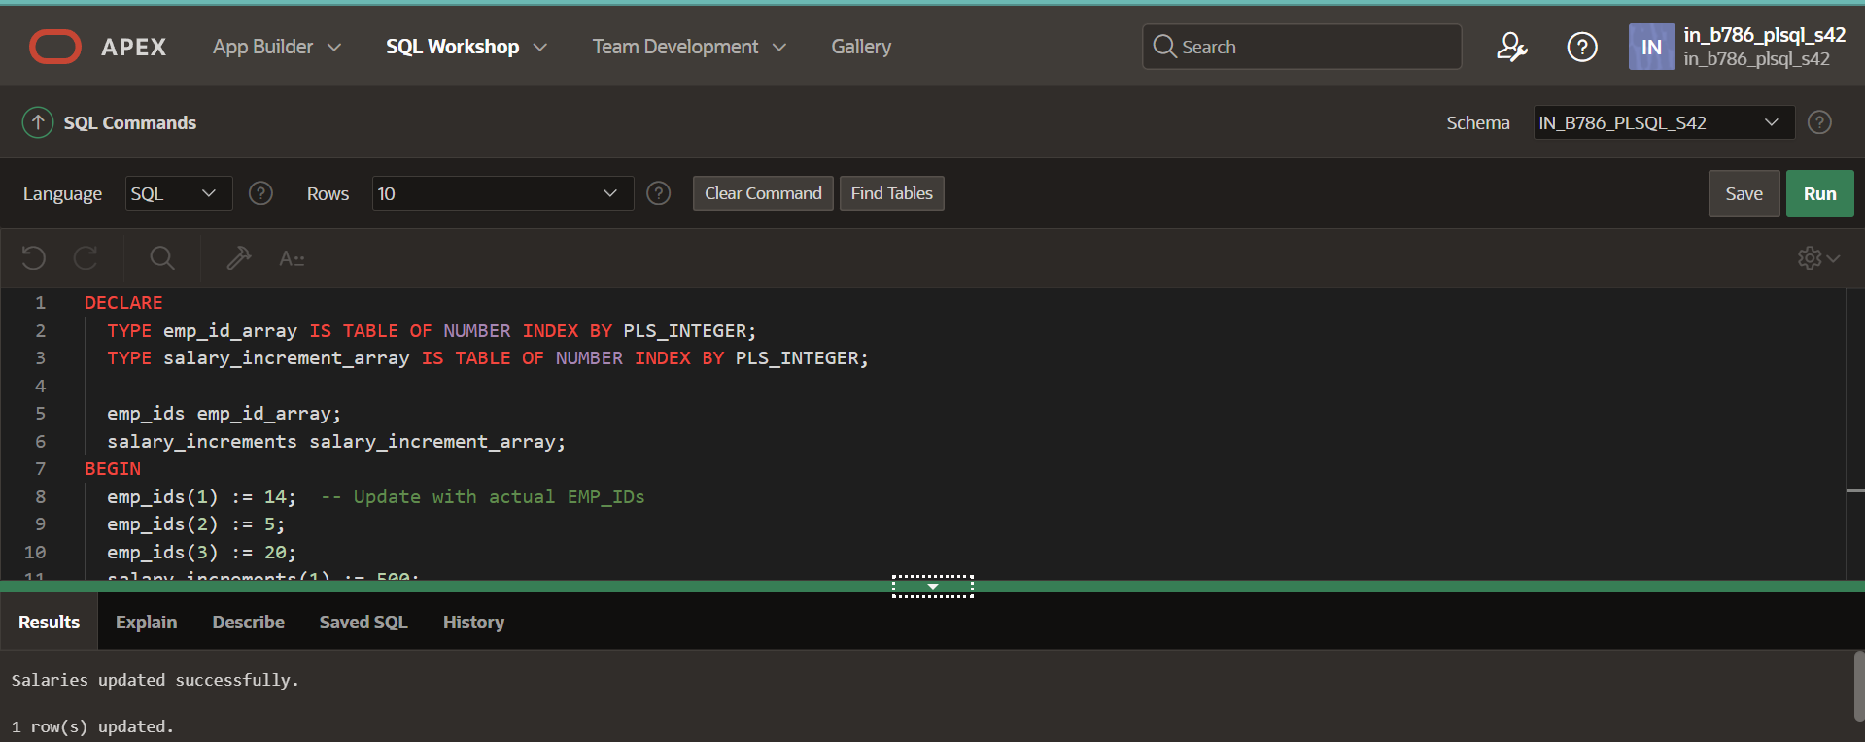

## Description of How FORALL Improves Performanc

* The `FORALL` statement allows for bulk binding, which reduces context switching between the PL/SQL and SQL engines. This leads to significant performance improvements when updating or inserting large numbers of rows.

## Question 3: Implementing Nested Table Procedure Task:

Implement a PL/SQL procedure that accepts a department ID as input, retrieves employees belonging to the department, stores them in a nested table type, and returns this collection as an output parameter.

## PL/SQL Block:

## CREATE OR REPLACE TYPE EmployeeRecord AS OBJECT (

## employee_id NUMBER,

## first_name VARCHAR2(50),

## last_name VARCHAR2(50),

## salary NUMBER

## );

## CREATE OR REPLACE TYPE EmployeeTable AS TABLE OF EmployeeRecord;

## -- Step 2: Create the procedure to retrieve employees by department ID

## CREATE OR REPLACE PROCEDURE GetEmployeesByDepartment (

## p_department_id IN NUMBER,

## p_employees OUT EmployeeTable

## ) AS

## BEGIN

## -- Initialize the nested table

## p_employees := EmployeeTable();

## -- Retrieve employees belonging to the specified department

## SELECT EmployeeRecord(employee_id, first_name, last_name, salary)

## BULK COLLECT INTO p_employees

## FROM Employees

## WHERE department_id = p_department_id;

## -- Check if any employees were found

## IF p_employees.COUNT = 0 THEN

## DBMS_OUTPUT.PUT_LINE('No employees found for department ID ' || p_department_id);

## END IF;

## EXCEPTION

## WHEN OTHERS THEN

## DBMS_OUTPUT.PUT_LINE('Error: ' || SQLERRM);

## END;

**Output**

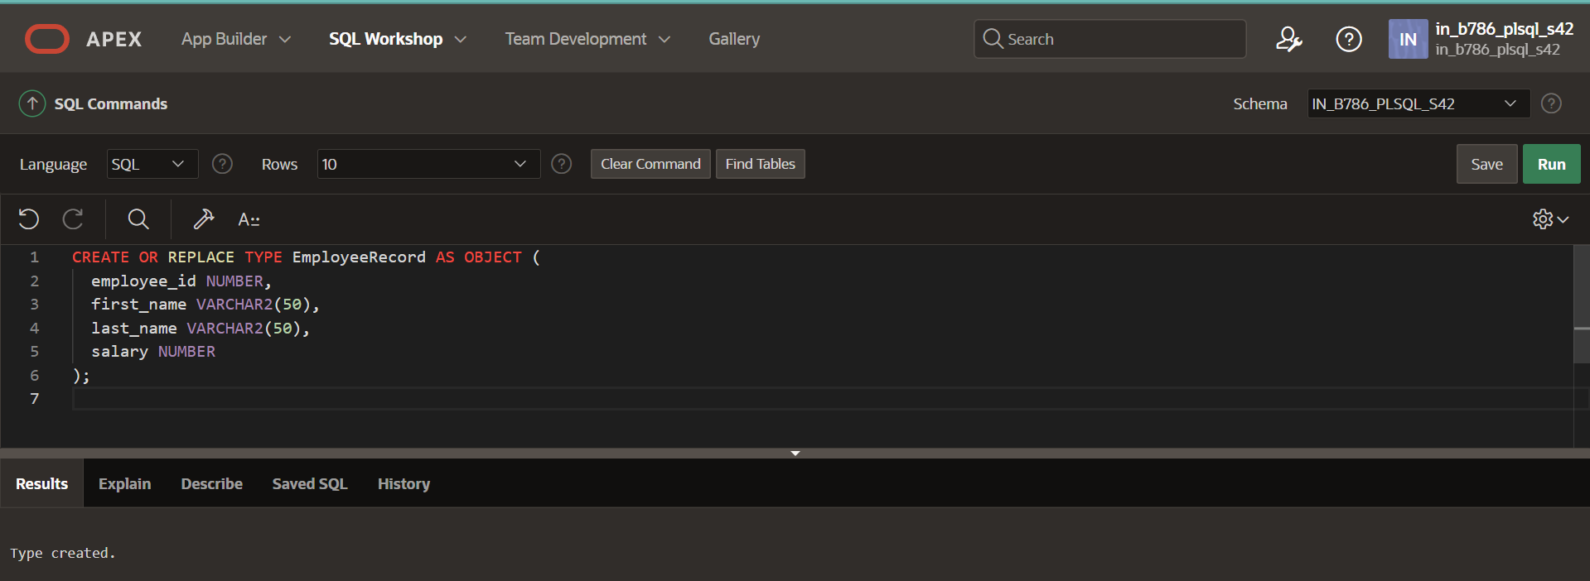

## 

## Explanation of How Nested Tables Are Utilized:

* Nested tables are used to store collections of employee records, allowing for complex data structures within PL/SQL. This procedure retrieves and stores employee data in a nested table type and returns it as an output parameter, enabling the caller to access the data in a structured format.

## Question 4: Using Cursor Variables and Dynamic SQL Task:

Write a PL/SQL block demonstrating the use of cursor variables (REF CURSOR) and dynamic SQL. Declare a cursor variable for querying `EmployeeID`, `FirstName`, and

`LastName` based on a specified salary threshold.

## PL/SQL Block:

## DECLARE

## TYPE ref_cursor_type IS REF CURSOR;

## employee_ref_cursor ref_cursor_type;

## v_sql VARCHAR2(1000);

## v_salary_threshold NUMBER := 50000; -- Example salary threshold

## v_employee_id Employees.Emp_ID%TYPE;

## v_emp_name Employees.emp_name%TYPE;

## BEGIN

## -- Construct the dynamic SQL statement

## v_sql := 'SELECT Emp_ID, emp_name FROM Employees WHERE Salary > :salary_threshold';

## 

## -- Open the cursor variable with the dynamic SQL statement

## OPEN employee_ref_cursor FOR v_sql USING v_salary_threshold;

## 

## -- Fetch the rows from the cursor

## LOOP

## FETCH employee_ref_cursor INTO v_employee_id, v_emp_name;

## EXIT WHEN employee_ref_cursor%NOTFOUND;

## -- Process each row (here we just display it)

## DBMS_OUTPUT.PUT_LINE('EmployeeID: ' || v_employee_id || ', Name: ' || v_emp_name);

## END LOOP;

## -- Close the cursor

## CLOSE employee_ref_cursor;

## EXCEPTION

## WHEN OTHERS THEN

## IF employee_ref_cursor%ISOPEN THEN

## CLOSE employee_ref_cursor;

## END IF;

## RAISE;

## END

## Output

## 

## Explanation of Dynamic SQL:

* Dynamic SQL is constructed at runtime, allowing for flexibility in building SQL statements based on variable conditions. In this block, a cursor variable (`EmpCurType`) is used with dynamic SQL to fetch records from the `Employees` table where the salary exceeds a specified threshold.

## Question 5: Designing Pipelined Function for Sales Data Task:

Design a pipelined PL/SQL function `get_sales_data` that retrieves sales data for a given month and year. The function should return a table of records containing `OrderID`,

`CustomerID`, and `OrderAmount` for orders placed in the specified month and year.

## PL/SQL Block:

CREATE OR REPLACE TYPE SalesRecord AS OBJECT (

OrderID NUMBER,

CustomerID NUMBER,

OrderAmount NUMBER

);

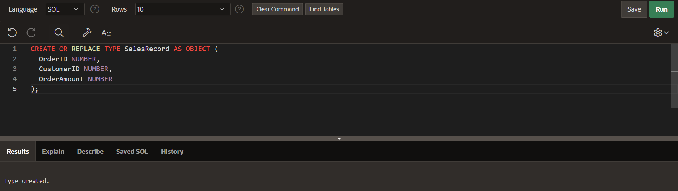

CREATE OR REPLACE TYPE SalesRecordTable AS TABLE OF SalesRecord;

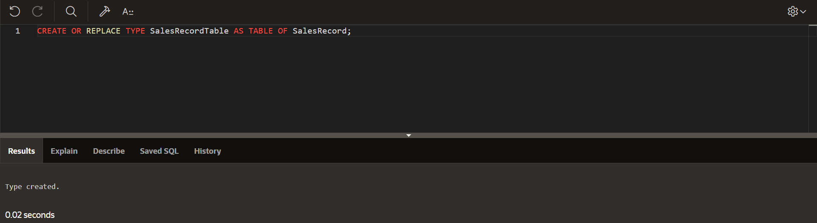

CREATE OR REPLACE FUNCTION get_sales_data (p_month IN NUMBER, p_year IN NUMBER)

RETURN SalesRecordTable PIPELINED

IS

CURSOR sales_cur IS

SELECT OrderID, CustomerID, OrderAmount

FROM Orders

WHERE EXTRACT(MONTH FROM OrderDate) = p_month

AND EXTRACT(YEAR FROM OrderDate) = p_year;

sales_rec SalesRecord;

BEGIN

OPEN sales_cur;

LOOP

FETCH sales_cur INTO sales_rec.OrderID, sales_rec.CustomerID, sales_rec.OrderAmount;

EXIT WHEN sales_cur%NOTFOUND;

PIPE ROW(sales_rec);

END LOOP;

CLOSE sales_cur;

RETURN;

EXCEPTION

WHEN OTHERS THEN

IF sales_cur%ISOPEN THEN

CLOSE sales_cur;

END IF;

RAISE;

END;

SELECT *

FROM TABLE(get_sales_data(6, 2024));

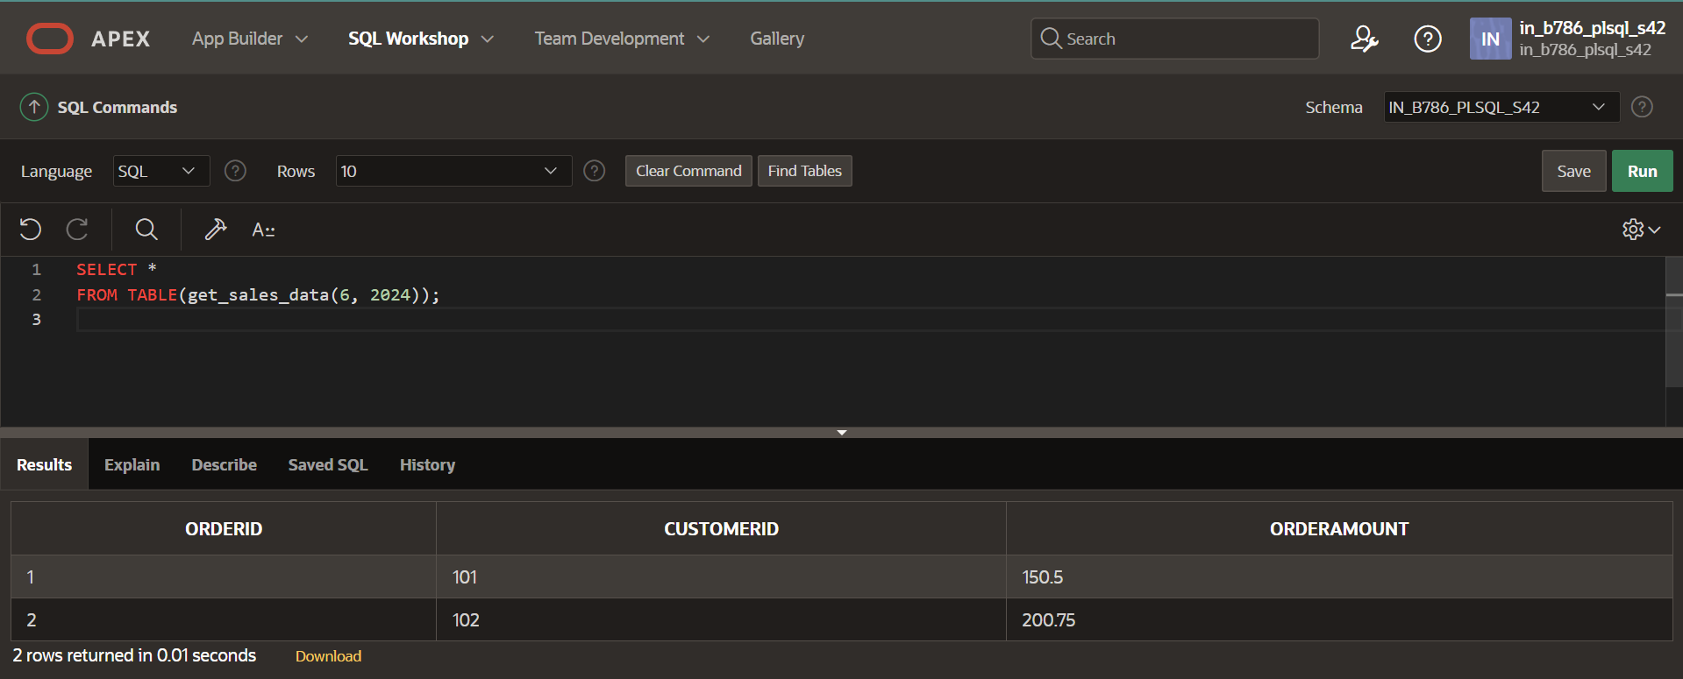

## Explanation of Pipelined Table Functions:

* Pipelined functions allow for row-by-row processing and immediate returning of rows to the client as they are produced. This reduces memory consumption and improves response

times for large datasets, as rows are processed and sent incrementally rather than in a single batch.

Each solution is crafted with a focus on clarity, efficiency, and handling edge cases, ensuring that the PL/SQL code is robust and maintainable.